MEDIA RELEASE
Australian Ambassador promotes gender equality projects in
Solukhumbu on International Women’s Day
Yesterday, Australia’s Ambassador to Nepal, HE Felicity Volk, and Member of the Province One Assembly, Mr Buddhi Kumar Rajbhandari, jointly inaugurated a newly constructed health post at Waku in Mapya Dudhkoshi Rural Municipality, Solukhumbu.
The Waku Health Post was jointly supported by a partnership of Australian and Nepali NGOs, including the Australian Himalayan Foundation (AHF), Action for Nepal and One Heart Worldwide, the Rural Municipality and the local community.
Addressing the event, Ambassador Volk said, “Australia’s love of Nepal and our commitment to walk as friends with Nepalis is well known. This spirit of practical friendship is embodied in AHF’s support to Waku and I’m very proud to represent the Australian connections to this project.”
Celebrating International Women’s Day in Solukhumbu, Ambassador Volk commended the vital contribution of female community health volunteers, nurses, doctors and mother’s groups to health care services in rural locations.
At the nearby Sagarmatha Secondary School, Ambassador Volk met with teachers delivering Australian Government funded distance education and teacher training programs through REED Nepal and AHF.
She said, “COVID-19 added new challenges to providing quality education for girls and boys, and girls have been disproportionately affected. So, Australia has prioritised a ‘Going to School Support’ program, providing distance education during the pandemic through FM radio and home visits by teachers.”
“As Nepal builds back better from the pandemic, Australia is standing beside students and teachers in Solukhumbu, including the young women leaders I’ve been delighted to talk to today,” said Ambassador Volk.

9 March 2022
Press Contact
KMDU.Media@dfat.gov.au
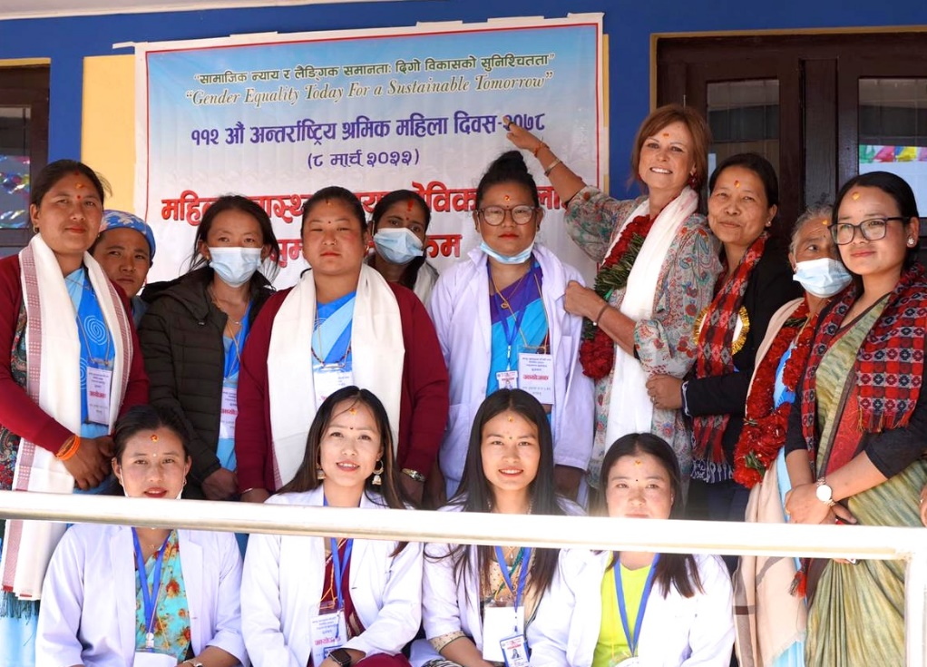
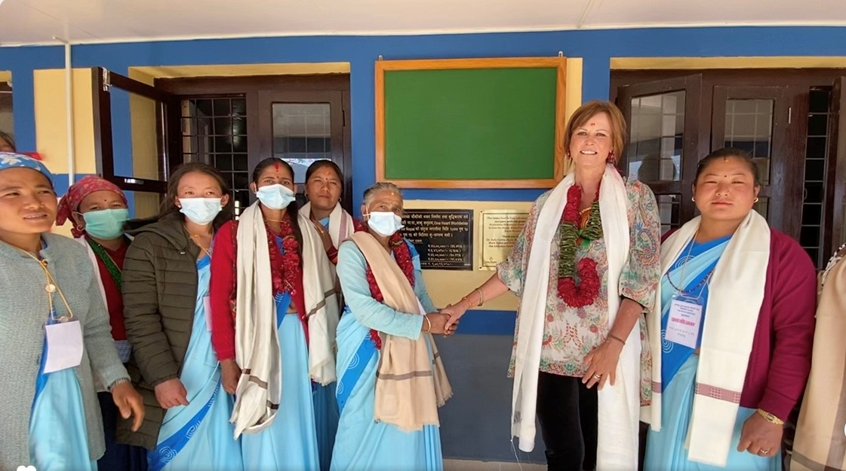
Images:
Australian Ambassador to Nepal HE Felicity Volk and Female Community Health Volunteers celebrate International Women’s Day at the newly constructed health post at Waku, Mapya Dudhkoshi Rural Municipality, Solukhumbu district on 8 March 2022. Photo: Action for Nepal

Australian Ambassador to Nepal HE Felicity Volk and Female Community Health Volunteers from Waku Health Post at Ward No. 6 of Mapya Dudhkoshi Rural Municipality celebrate International Women’s Day at the newly constructed health post building at Waku, Mapya Dudhkoshi Rural Municipality, Solukhumbu district on 8 March 2022. Photo: Australian Embassy

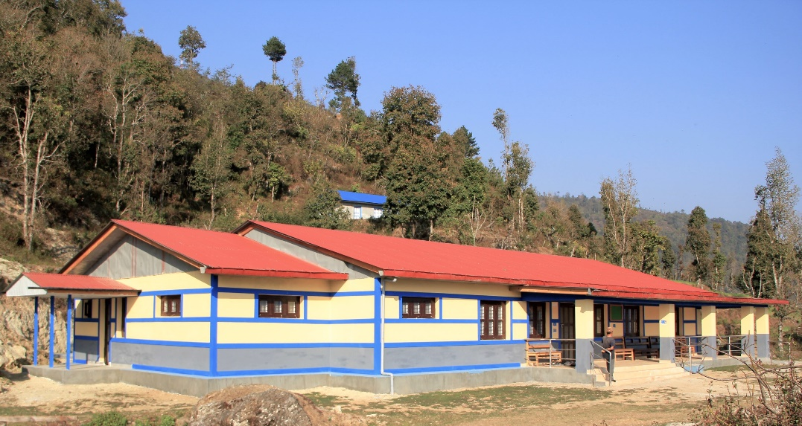
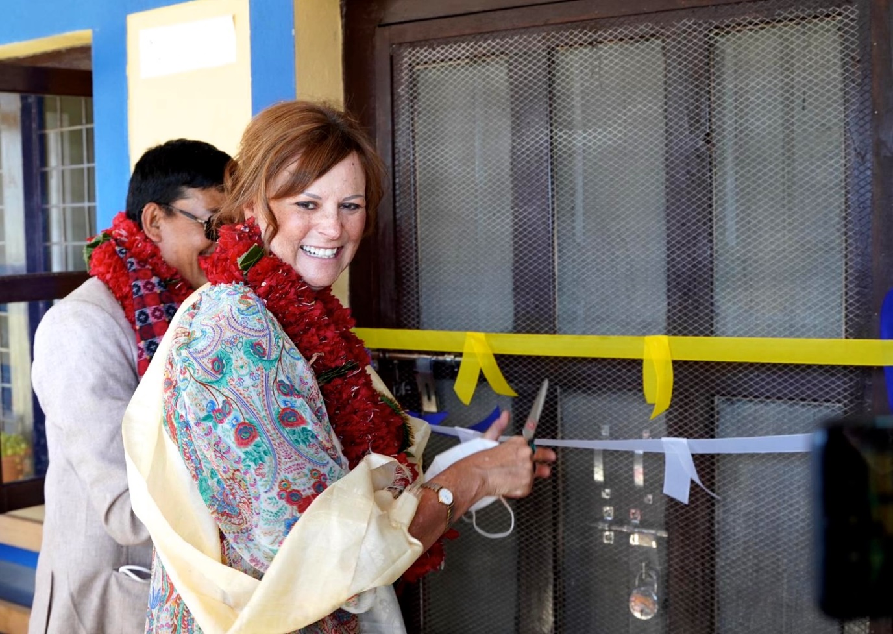
Newly constructed health post at Waku, Ward No 6 of Mapya Dudkhoshi Rural Municipality, Solukhumbu district. The health post was constructed with joint efforts of the rural municipality and local community with support from the Australian Himalayan Foundation, Action for Nepal and One Heart Worldwide. Photo: Action for Nepal
Australia’s Ambassador to Nepal HE Felicity Volk and Member of the Province One Assembly, Hon Mr Buddhi Kumar Rajbhandari jointly inaugurate the newly constructed health post at Waku, Mapya Dudhkoshi Rural Municipality, Solukhumbu on 8 March 2022. Photo: Action for Nepal
Background information:
- The Mapya Dudhkoshi Rural Municipality, Australian Himalayan Foundation, Action for Nepal, One Heart Foundation and local residents of Waku, Solukhumbu jointly contributed funds of approximately
AUD 170,000 and 22,000 square feet of land to construct a new health post building with a birthing centre at Waku.
- The new health centre will benefit more than 5100 people living in Waku including the 820 students of the 13 surrounding schools. The new health centre includes a separate outpatient department (OPD) room, family planning room, emergency room, a store for medicines, antenatal care (ANC) room, delivery room and a sterilisation room. There are separate toilets for male and female patients and for staff.
- Through Australia’s COVID-19 Emergency Response for Nepal, the Australian Government has provided $500,000 to support Rural Education and Environment Development Center (REED) Nepal to implement a project “Promoting Stability in Education: Continuity of Learning and Strengthening Resilience in Nepal”.
- The project activities aim to address the disruption of education of children due to COVID-19 pandemic, support local governments to improve their capacity to deliver quality education services through effective and efficient implementation of existing policies and guideline to continue education through disasters in 44 schools in Solukhumbu district out of the total 141 schools across different provinces and districts.
- In partnership with the Rural Education and Environmental Development Centre (REED Nepal), AHF’s flagship program the Teacher Training and Quality Inclusive Education project (TTQIE) will help children living in some of the poorest and most remote areas of the Himalaya to access inclusive, high quality primary education. This project is supported by the Australian Government through the Australian NGO Cooperation Program (ANCP). The TTQE program commenced in 2005. The latest 5-year project phase (1 July 2021 to 30 June 2026) follows an earlier successful version of the program which ran from 2018-2021. Drawing on the learnings of the earlier project, TTQIE will have an increased focus on inclusion of vulnerable groups such as girls and children with a disability.

